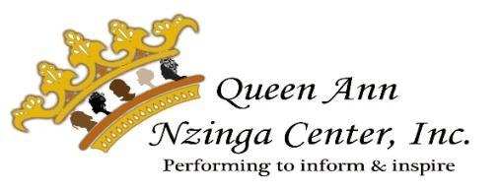
Youth Program Registration

The Queen Ann Nzinga Center, Inc. (QANC) is a non-profit organization specializing in cultural education and social change. The Center offers expressive arts-based programs to children and youth throughout the school year. These programs are designed to build self-esteem, enhance life skills, and foster creativity in an environment that celebrates diversity and provides inter-generational mentoring. Our programs:

- Provide a safe, fun learning environment for all children
- Encourage children to be understanding and tolerant of others
- Provide performing arts experiences with professional training
- Foster the development of team building skills and a strong sense of responsibility

Join QANC’s Watoto Programs 2023/2024
Activity / Group: ____________________________________________________________________________________________________
Purpose & Goal: ____________________________________________________________________________________________________
When: Day(s)____________________________Time:______ _____________ Beginning Date:_________________ Ending:___ __________
Location Site/Meeting Place: Trinity-on-Main in Stockman Hall at 19 Chestnut Street, New Britain, CT. Events/rehearsals are held at community locations that follow health and safety protocols. Guardians will be notified of any location changes.

Permissions for Participation

I, (guardian’s printed name) ____________________________________________ give my child, (name)___________________________________ permission to participate in the Watoto program and events offered by the Queen Ann Nzinga Center, Inc.

Child’s Full Name:___________________________________________ Date of Birth: ____________ Age: ____ School:___________________

Street address:_____________________________________________ City/State/Zip:______________________________________________

Phone number:____________________________________________ Email address:_______________________________________________

Gender Identity: Male | Female | Other ________ Prefer Not to Answer T-shirt Size: Youth -or- Adult? XS | S | M | L | XL | 2XL | 3XL

Emergency Contact:_________________________________________ Relation to child:________________ Phone number: _______________

I agree to support my child’s participation. I understand that I may call the sponsor/facilitator(s) directly if I have any questions regarding the activity or have any concerns regarding my child. I understand that I have/my child has the right to be treated with dignity and respect. I understand that my child’s rights to confidentiality are protected under Federal and State Confidentiality Regulations, and that information cannot be disclosed without my consent UNLESS my child’s safety is assessed to be in imminent danger or otherwise provided for in the regulations. I release, acquit, and discharge the Queen Ann Nzinga Center Inc. from any and all liability, claims, demands, actions, and causes of action which I, or my representatives, may have by reason of an accident which might occur while engaged in the previously-mentioned Queen Ann Nzinga Center, Inc. program(s).

Parent/Guardian Signature:___________________________________________________________________ Date: ____________________
Child’s Signature (8 years and older) ____________________________________________________________ Date:_____________________

Permission to Photograph, Video Record in person or during Zoom meetings
I hereby give Queen Ann Nzinga Center, Inc. permission to photograph or video record myself and my child during activities sponsored by Queen Ann Nzinga Center, Inc. The photographs and videos may be used at a later date for the purpose of promoting activities and for public relations campaigns of the agency. At any time, you can withdraw consent for future use of photographs and video recording by addressing a note stating your wishes to Dayna R. Snell, Executive Director, Queen Ann Nzinga Center, Inc., email: qancinc@gmail.com.

Parent/Guardian Signature:___________________________________________________________________ Date: _____________________

Permission to Transport
I hereby give Queen Ann Nzinga Center, Inc. staff and volunteers permission to transport my child to, from, and during activities sponsored by Queen Ann Nzinga Center, Inc.

Parent/Guardian Signature:___________________________________________________________________ Date: _____________________

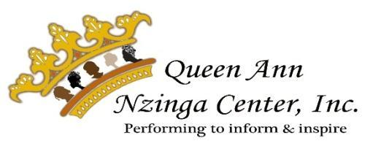

Medical Information and Waiver Form

Child's name ______________________________________________________ D.O.B__________________ Age: ______________________

Parent/guardian name ______________________________________________ Phone Number:______________________________________

Street address_____________________________________________________ Mailing address, if different ____________________________

City______________________________ State _________ Zip Code__________ City_________________________ State _____ Zip__________

Emergency Contact 1:_______________________________________________ Phone Number: _____________________________________
Emergency Contact 2: _______________________________________________ Phone Number: _____________________________________

Name of healthcare provider __________________________________________ Phone Number: ______________________________________

Does your child have a food allergy that may be life-threatening? ⃝ Yes ⃝ No

Check the foods that have caused an allergic reaction in the past or recently: (Check all that apply)

- Peanuts ⃝ Peanut or nut butter
- Peanut or nut oils ⃝ Tree nuts (walnuts, almonds, pecans, etc.)
- Eggs ⃝ Fish/Shellfish
- Soy Products ⃝ Milk
- Gluten
- Other _________________________________________________________________________________________________________

What was your child doing when they had a reaction to problem foods? (Check all that apply)

- Eating foods
- Touching foods
- Smelling foods
- Other _________________________________________________________________________________________________________

Allergies - other than food: ________________________________________________________________________________________________________________________________________________________________________________________________________________________________________________

What are the signs and symptoms of your student’s allergic reaction? (Be specific please; include things the student might say.)

_______________________________________________________________________________________________________________________

_______________________________________________________________________________________________________________________

Does your child have any medical condition(s)? (such as, but not limited to: asthma, seizures, heart or orthopedic condition, etc.)

________________________________________________________________________________________________________________________

________________________________________________________________________________________________________________________
________________________________________________________________________________________________________________________

Will your child need medicine or treatment of a medical condition during their participation at a QANC class or event? _______________________

If you answered “yes”, please describe the medicine or treatment of a medical condition _______________________________________________

________________________________________________________________________________________________________________________

________________________________________________________________________________________________________________________
____

Does your child have any special learning style or educational techniques that will be helpful to know to maximize his/her success?

________________________________________________________________________________________________________________________

________________________________________________________________________________________________________________________

Should an injury or accident occur, I grant permission for my child to receive necessary emergency treatment by licensed or certified
medical personnel at the nearest medical facility. I should be contacted at the emergency contact information below:

Contact 1: Contact 2:

_____________________________________________________ _____________________________________________________

_____________________________________________________ _____________________________________________________

As with any activity, I am aware that certain risks of injury may exist. Should an injury or accident occur, I will not hold Queen Ann Nzinga
Center, Inc. or any of its staff, contractors, volunteers, or concerns liable, and I give my permission for my child to participate.

Parent/Guardian Signature _________________________________________________________ Date: __________________________

Parent/Guardian Printed Name: _____________________________________________________

